UCSB Sedgwick Reserve, Winter 2017

final report on amphibian surveys

Andrea J. Adams and Emily A. Wilson

UCSB Ecology, Evolution, and Marine Biology

**Table of Contents**

Executive Summary 3

1. Study Goal and Objectives 1

2.0 Study Methods and Analysis 1

2.1 Study Area 1

2.2 Study Methods 1

2.3 Results 3

Summary of results 3

Site 1 - Bass Pond 4

Site 2 - Blue Schist Spring 6

Site 3 - Cloud’s Rest Pond 7

Site 4 - Concrete Cylinder Pool 9

Site 5 - Lower Figueroa Creek 11

Site 6 - Goldfinch Pond 13

Site 7 - Goldfinch Trough 15

Site 8 - Hidden Spring 17

Site 9 - Ladder Trough 19

Site 10 - Massey Spring 21

Site 11 - Tipton House Pond 22

Site 12 - Vernal Pools 23

## Executive Summary

Here we report on the results of amphibian surveys at UC Santa Barbara’s Sedgwick Reserve (Reserve), conducted in the winter of 2017. We evaluated potential survey sites on the Reserve in November 2016 and conducted amphibian surveys at 12 sites (2 lotic and 10 lentic) between January and March 2017. The Reserve has high quality habitat that can provide refuge and breeding for several amphibian species. Amphibians observed include the California red-legged frog (*Rana draytonii*), Western toad (*Anaxyrus boreas*), Arboreal salamander (*Aneides lugubris*), and Pacific chorus frog (*Hyliola regilla*). The Western toad and Pacific chorus frog appear to be breeding successfully to the larval stage but additional surveys will be necessary to determine if the California red-legged frog attempts to breed at the sites where it was observed and whether or not any species’ breeding attempts result in successful recruitment. We recommend that the Reserve manage for optimal amphibian habitat at these sites through eradication and prevention of non-native predators and competitors, and that surveys be conducted later in amphibian breeding season for confirmation of breeding at suitable sites. We also recommend that appropriate (protocols different from those employed for this study) upland and aquatic surveys be conducted for California tiger salamanders (*Ambystoma californiense*) and Western spadefoot toads (*Spea hammondii*) as these sensitive species would be a significant conservation and research asset for the Reserve, the region, and the UC Natural Reserve System as a whole.

## 1. Study Goal and Objectives

**Goal:** To collect information about the occupancy and status of amphibians on the Sedgwick Reserve (Reserve).

**Objectives:**

* Identify and monitor habitats in the study area potentially suitable for amphibians, and evaluate the suitability of these habitats.
* Perform biological surveys in suitable habitats between January and March 2017.
* Report on findings of biological surveys and provide recommendations for restoration of potential amphibian habitats.

## 2.0 Study Methods and Analysis

### 2.1 Study Area

The study area consists of streams, seeps, ponds, and water troughs on the Reserve. These include, in alphabetical order: 1) Bass Pond; 2) Blue Schist Spring; 3) Cloud’s Rest Pond; 4) Concrete Cylinder Pool; 5) Lower Figueroa Creek; 6) Goldfinch Pond; 7) Goldfinch Trough; 8) Hidden Spring; 9) Ladder Trough; 10) Massey Spring; 11) Tipton House Pond; 12) Vernal Pools.

### 2.2 Study Methods

We monitored the 12 sites above during the study period for water levels conducive to amphibian refuge and/or breeding. In addition to habitat conditions, the selection of survey sites took into account site-specific conditions, including safety, and accessibility (*i.e.*, road or trail access, topography). We conducted amphibian surveys on the Reserve between January 20 and March 18, 2017. Surveys for amphibians on the reserve followed [guidelines](https://www.fws.gov/sacramento/es/survey-protocols-guidelines/documents/crf_survey_guidance_aug2005.pdf) outlined by the U.S. Fish and Wildlife Service (USFWS) for California red-legged frogs[1]. Together, we searched sites 1-12 (see **Study Area** above) following the aforementioned survey guidance. We recorded habitat assessment and amphibian detection information by life stage on datasheets provided by USFWS (see Appendix E in guidelines link above). On the datasheets, we recorded weather metrics (i.e., wind speed, moon phase, precipitation, cloud cover, air temperature, humidity) and water metrics (ie., water depth and temperature) and habitat characteristics in addition to amphibian life stages observed at each site. We also noted whether there were any native or non-native species present that are considered threats or predators to amphibians.

### 2.3 Results

### Summary of results

Amphibians were observed at 10 of the 12 sites, and evidence of breeding (either egg clutches and/or tadpoles) was observed at seven sites. We had anticipated observations of California newts (*Taricha torosa*) at the Figueroa Creek and Hidden Springs sites, as well as Western spadefoot toads (*Spea hammondii*) at the vernal pools but we did not observe these species. One additional amphibian species, the arboreal salamander (*Aneides lugubris*), was found at the Ladder Trough site.

|  |  |  |  |  |
| --- | --- | --- | --- | --- |
|  | **Western Toad** | **Pacific Chorus Frog** | **California Red-legged Frog** | **Arboreal Salamander** |
| **Bass Pond** | Observed (breeding) | Observed | Observed | - |
| **Blue Schist Spring** | - | - | - | - |
| **Cloud’s Rest Pond** | - | Observed (breeding) | - | - |
| **Concrete Cylinder Pool** | - | Observed (breeding) | - | - |
| **Lower Figueroa Creek** | Observed | Observed | Observed | - |
| **Goldfinch Pond** | Observed | Observed (breeding) | - | - |
| **Goldfinch Trough** | Observed | Observed (breeding) | - | - |
| **Hidden Spring** | - | Heard only | - | - |
| **Ladder Trough** | - | Observed (breeding) | - | Observed |
| **Massey Spring** | Observed | - | - | - |
| **Tipton House Pond** | - | Observed (breeding) | - | - |
| **Vernal Pools** | - | - | - | - |

**Site-specific results**

### Site 1 - Bass Pond

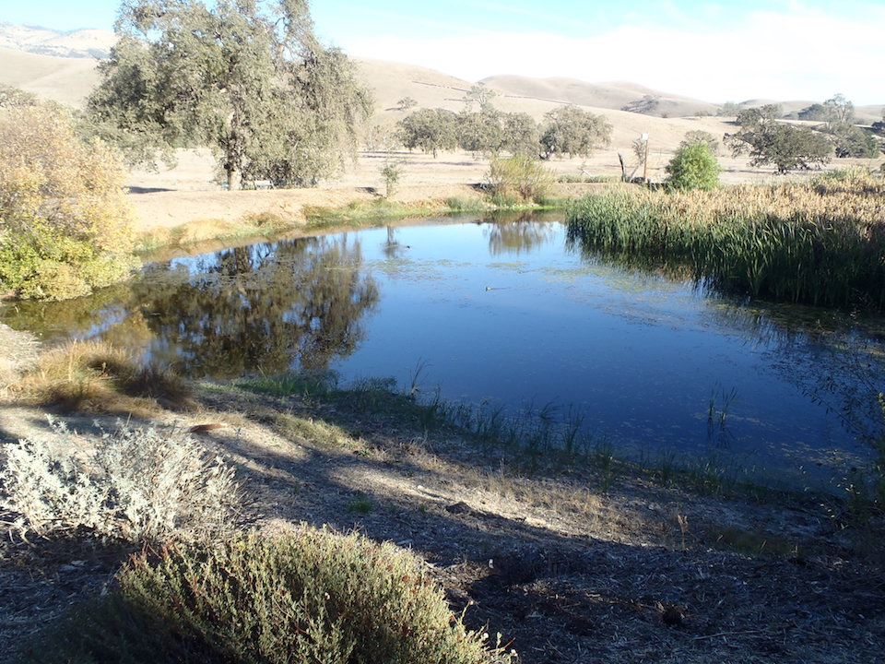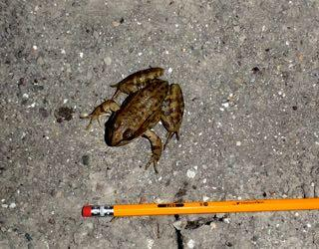

Left: The Bass Pond viewed from the north end.

Right: The California red-legged frog found on the road immediately next to the pond on March 18, 2017.

**Amphibian habitat suitability:**

This site includes an approximately 0.3-hectare pond that holds water year-round. The south end of the pond is thick with cattails that provide nesting habitat for resident birds. We conducted 3 day surveys and 3 night surveys at this site between January 21 and March 18 2017. We heard Pacific chorus frog males calling at this site and observed western toads on road directly above the pond. On the evening of March 17, we observed a single California red-legged frog on the road directly above the pond. On March 18, we observed characteristic strands of western toad eggs on the northern shore; however, they were damaged and appeared to have been unviable; possibly from disturbance by non-native species (i.e., crayfish or mosquitofish). Another nearby clutch of western toad eggs had recently hatched within the last few days.

**Total amphibian observations at Bass Pond:**

|  |  |  |  |
| --- | --- | --- | --- |
| **Species** | **Egg masses** | **tadpoles** | **juv/adult** |
| Western toad | 3 (unviable) | ~2,000 | 1 |
| Pacific chorus frog | 0 | 0 | 4 (heard); 1 (observed) |
| California red-legged frog | 0 | 0 | 1 |

**Non-native species present:** Crayfish (shells), bass, mosquitofish, raccoon (tracks)

**Recommendations:**

This pond provides excellent habitat for amphibian breeding except for the presence of invasive species. Amphibians are present nearby and may be attempting to breed in the pond. As with the toad eggs, any attempts to breed in the pond are likely to fail before they reach metamorphosis. Our primary recommendation for this site is to remove non-native predators (i.e., bass, mosquitofish, crayfish) through draining in order to eradicate them and provide suitable habitat for native species, especially the California red-legged frog. There is a cover board in the grass just south of the berm on the south side of the pond that could be regularly checked for amphibians and reptiles. On March 18 during our day survey, we observed a red-tailed hawk perched low in a tree at the site with behavior and characteristics suggestive of rodenticide poisoning. We recommend that Reserve administrators coordinate with nearby landowners to reduce rodenticide use, which can poison and injure non-target predators, and urge them to switch to live trapping of undesirable rodents.

### **Site 2 - Blue Schist Spring**

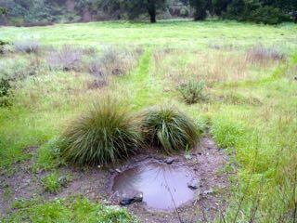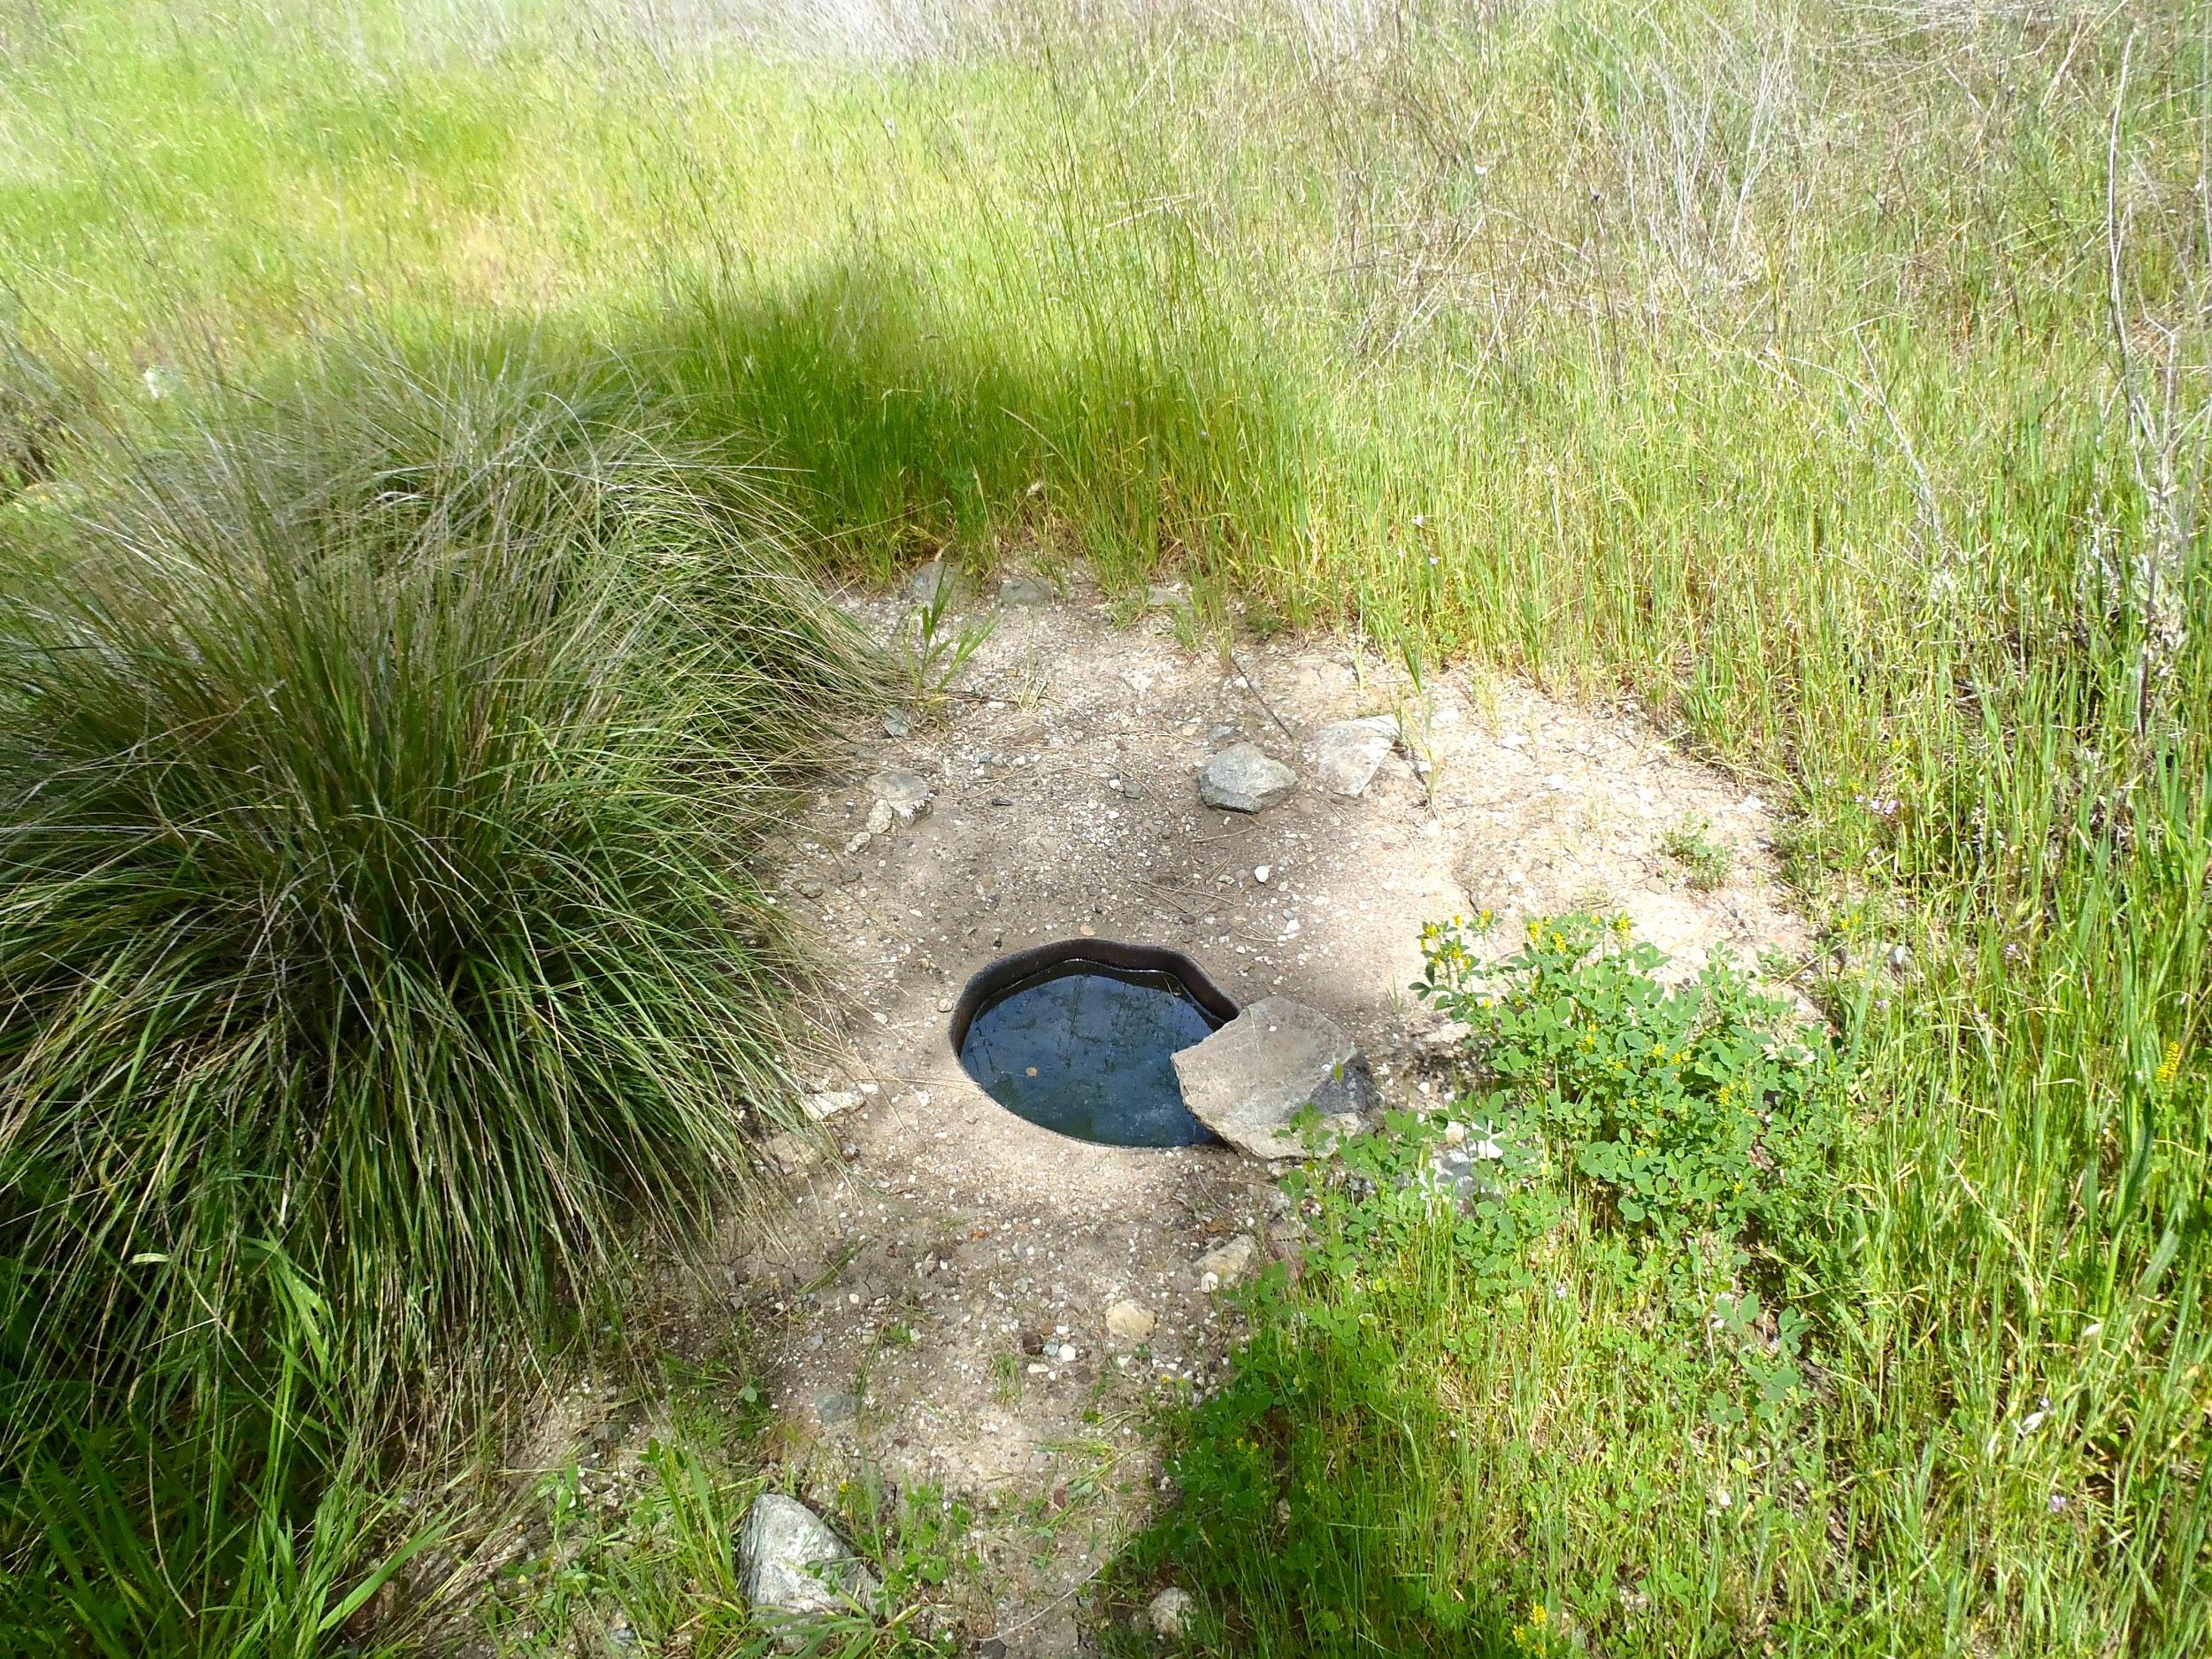

Left: Blue Schist site on February 18, 2017.

Right: Blue Schist site on March 18, 2017.

**Amphibian habitat suitability:**

Spring water is collected and piped into a pool that is approximately 1 meter in diameter and 0.3 meters deep with a mud and gravel bottom and bank. The spring pool is next to a large grass area and is approximately 100 meters from the streambed. The water is available year-round, which is valuable because the nearby creek quickly becomes dry after rains. However, the spring pool is likely not large enough for any amphibians other than a Pacific chorus frog to breed in. The water level fluctuates slightly but it appears to remain at least several inches deep year round.

We conducted 3 day surveys and 3 night surveys at this site between January 21 and March 18 2017. No amphibians were observed or heard during the surveys. However, one Western toad was observed on the March 18 day survey on the road approximately 30 meters from the spring. The western toad was tucked into a rodent hole in the middle of the road.

**Total amphibian observations at Blue Schist Spring:** 0

**Non-native species:** None observed.

**Recommendations:**

This spring pool should be kept with water year round for both refugia and breeding.

### Site 3 - Cloud’s Rest Pond

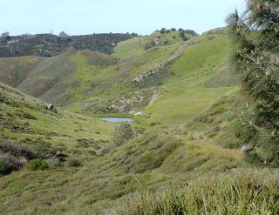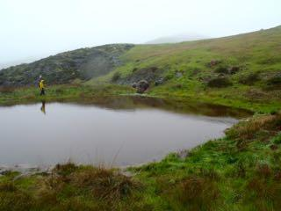

Left: Cloud’s Rest Pond on March 18, 2017.

Right: Cloud’s Rest pond on February 18th, 2017.

**Amphibian habitat suitability:**

This site is an ephemeral pond in the northernmost portion of Sedgwick Reserve. The pond is in a hilly setting dominated by grasses and other short shrub vegetation with some rock outcrops. There is small spring above the pond but it is not enough to flow into or feed the pond. Following rains, the pond is formed in a large depression along a creek, approximately 26.5 meters in diameter at its widest point. The pond was dry in November but was holding water at the first survey on January 21, which occurred after heavy rains. It remained wetted throughout the survey period, although the creek went dry by the last visit on March 18.

We conducted 3 day surveys and 3 night surveys at this site between January 21 and March 18 2017. Calling male Pacific chorus frogs were observed in and around the pond on each night survey. There were at least ten male Pacific chorus frogs at this site calling on the March 17 night survey. The Pacific chorus frogs appear to be successfully breeding at this site because tadpoles were observed in the pond on the March 18 survey. The area does have Western toads, as some were seen on Figueroa Mountain Road on the way to the site, but those toads were about a mile from the site.

**Total amphibian observations at Cloud’s Rest Pond:**

|  |  |  |  |
| --- | --- | --- | --- |
| **Species** | **Egg masses** | **tadpoles** | **juv/adult** |
| Pacific chorus frog | 0 | >500 | >10 (10 heard; 6 observed) |

**Non-native species:** None observed.

**Recommendations:**

This pond provides good breeding habitat for native amphibians and is at lower risk of invasive species introduction because of its ephemeral nature and relatively remote location. No changes need to be made to this site as it can be used by Pacific chorus frogs and likely Western toads. The pond would also make ideal habitat for California tiger salamander (*Ambystoma californiense*) breeding, and the pond occurs just outside of their [estimated known range](https://ecos.fws.gov/docs/recovery_plan/SB%20CTS%20Final%20RP%20Signed_1.pdf). In addition, the grasslands surrounding the pond would provide good upland habitat for California tiger salamanders, which is where they spend the large majority of their life cycle--in underground burrows away from water. Our surveys were insufficient to confirm California tiger salamander presence or absence because we did not survey the pond with dip nets or the uplands with drift fencing, which are the survey techniques necessary to detect this species. If California tiger salamanders are present at the Reserve, it would be a significant conservation and research asset for the region and the UC Natural Reserve System. To determine California tiger salamander presence or absence, we recommend that they undertake the survey protocol for California tiger salamanders in coordination with the U.S. Fish and Wildlife Service, as the Santa Barbara County Distinct Population Segment of California tiger salamanders is listed as endangered under the federal Endangered Species Act.

### Site 4 - Concrete Cylinder Pool

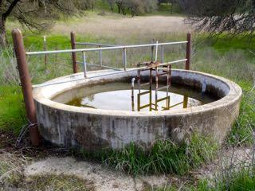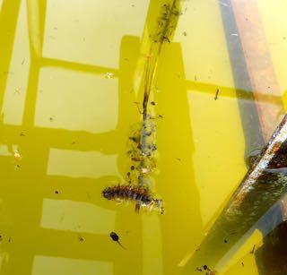

Left: The Concrete Cylinder Pool on January 21, 2017.

Right: A Pacific chorus frog tadpole (bottom), caterpillar, and two Pacific chorus frog egg clutches attached to a stalk of grass on March 18, 2017.

**Amphibian habitat suitability:**

This site is a concrete cylinder tank with walls approximately 75 cm high and is 3 meters in diameter with a maximum depth of approximately 40 cm. It is located approximately 400 meters south of Blue Schist Spring. The tank appears to hold water year round.

We conducted 3 day surveys and 2 night surveys at this site between January 21 and March 18 2017. The high concrete walls make it inaccessible to most amphibians except Pacific chorus frogs. Adult male Pacific chorus frogs were observed at the site on multiple surveys and on one visit five males were observed calling in the water. The Pacific chorus frogs are breeding in this tank as evident by multiple egg clutches and hundreds of tadpoles. Turbidity of the water makes estimating the number of tadpoles present challenging, but on the March 18 visit we estimated there were over 300 tadpoles in the tank in a range of size classes.

**Total amphibian observations at Concrete Cylinder Pool:**

|  |  |  |  |
| --- | --- | --- | --- |
| **Species** | **Egg masses** | **tadpoles** | **juv/adult** |
| Pacific chorus frog | 4 | >300 | >5 |

**Non-native species:** None observed.

**Recommendations:**

Metal grates or other ramps should be placed along the sides of the pool to prevent amphibians from becoming trapped in the cylinder when water levels are low.

### Site 5 - Lower Figueroa Creek

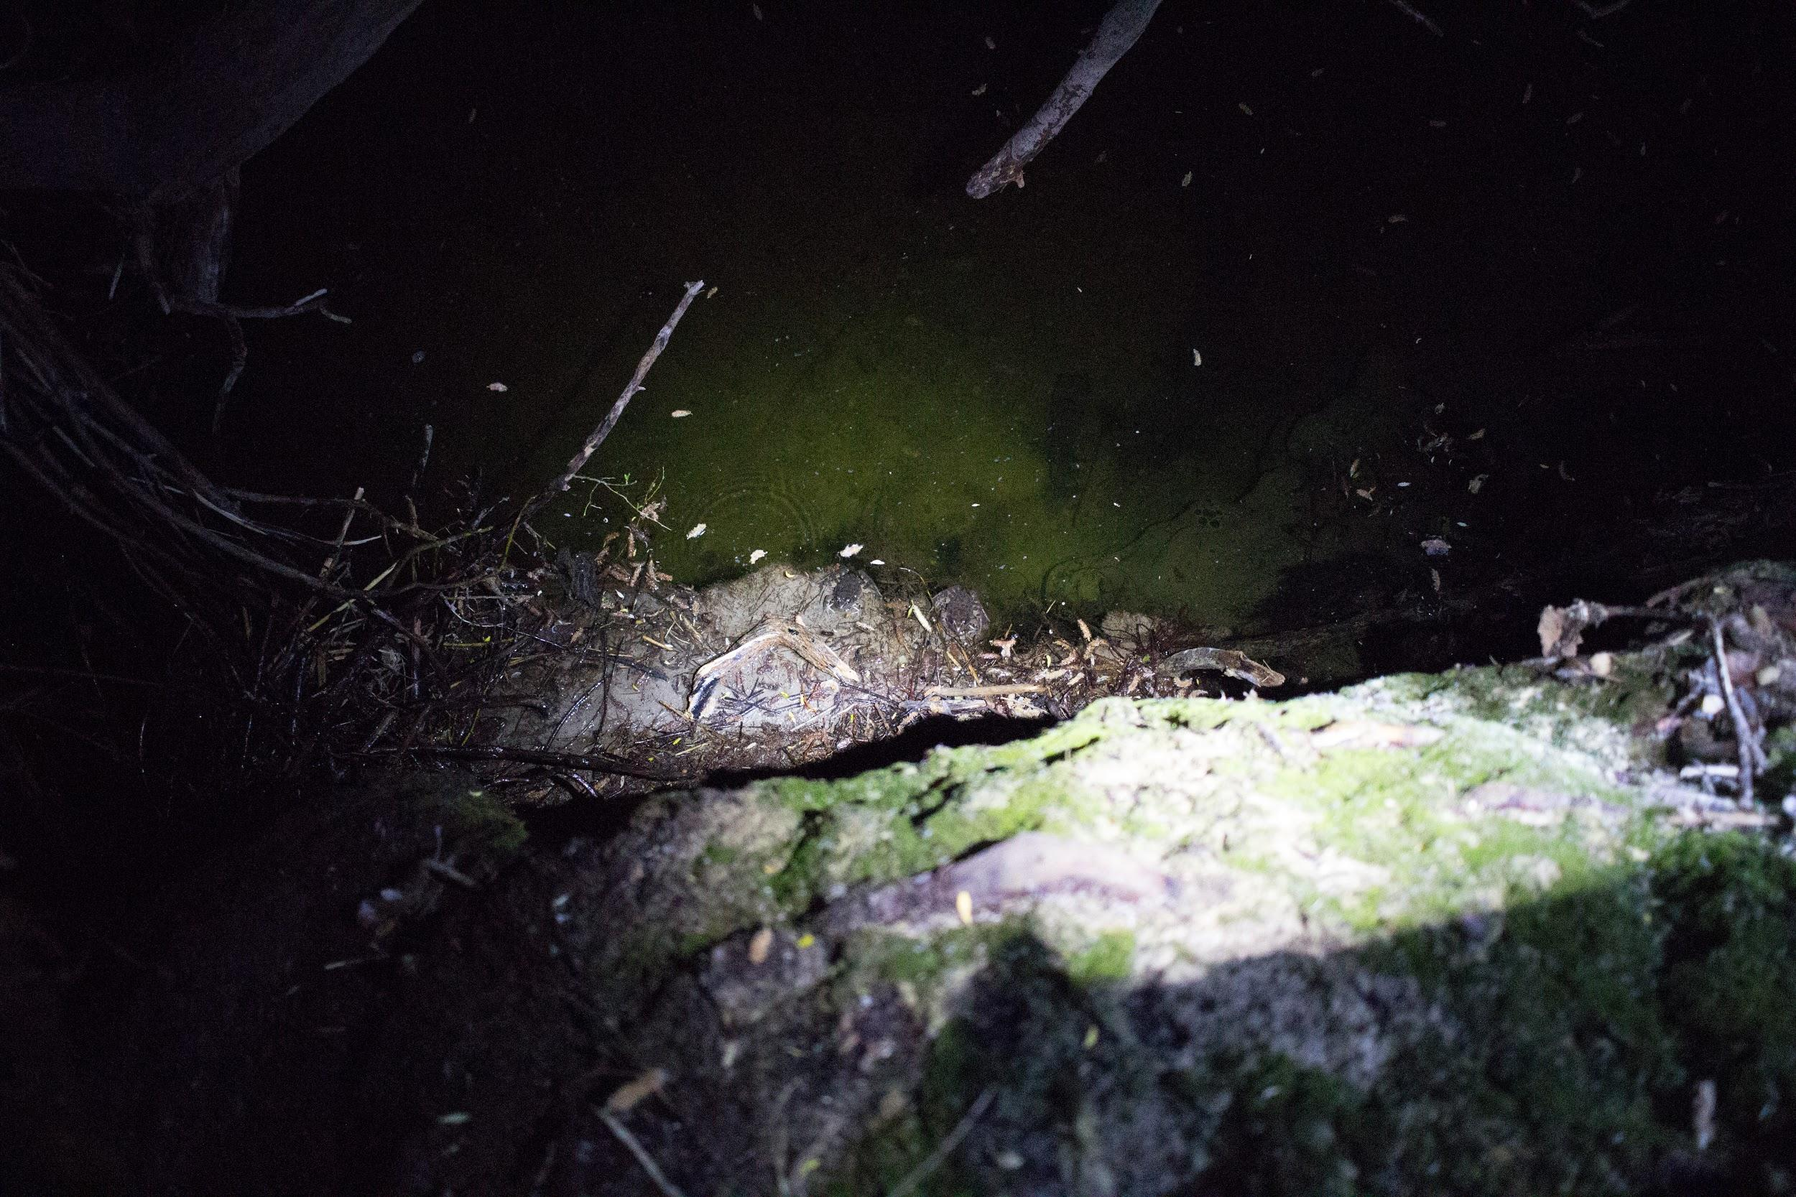

Two California red-legged frogs (center) on the bank of a pool in lower Figueroa Creek on March 17, 2017.

**Amphibian habitat suitability:**

Lower Figueroa Creek is a perennial stream that provides diverse riffle, pool, and stream habitat for amphibians. Overhanging banks provide ideal cover habitat for California red-legged frogs. On a preliminary site visit on November 15, 2016, we observed what we are 95% certain was a California red-legged frog that jumped into the stream, based on a brief observation of diagnostic dorsolateral folds. We conducted three day surveys and three night surveys at this site between February 4 and March 17, 2017. Pacific chorus frogs could often be heard calling at various sites along the stream. On March 17, we observed two California red-legged frogs and a western toad in the pool below the bridge. That evening, we observed 7 California red-legged frogs in the same pool, two just upstream in another pool, and two more in a pool further upstream of the cattle fence that crosses the stream.

**Total amphibian observations at Lower Figueroa Creek:**

|  |  |  |  |
| --- | --- | --- | --- |
| **Species** | **Egg masses** | **tadpoles** | **juv/adult** |
| Western toad | 0 | 0 | 2 |
| Pacific chorus frog | 0 | 0 | 37 (heard); 11 (observed) |
| California red-legged frog | 0 | 0 | 13 |

**Non-native species:** We observed small fish in the creek, but were unable to identify them to species.

**Recommendations:**

We recommend continuing to survey this site later in the rainy/spring season to confirm California red-legged frog breeding. It is encouraging that this threatened species is present in relatively large numbers at the Reserve. In addition, we recommend continuing to monitor the creek for invasive species (i.e., mosquitofish, bullfrogs) that could predate or out-compete the California red-legged frogs present.

### Site 6 - Goldfinch Pond

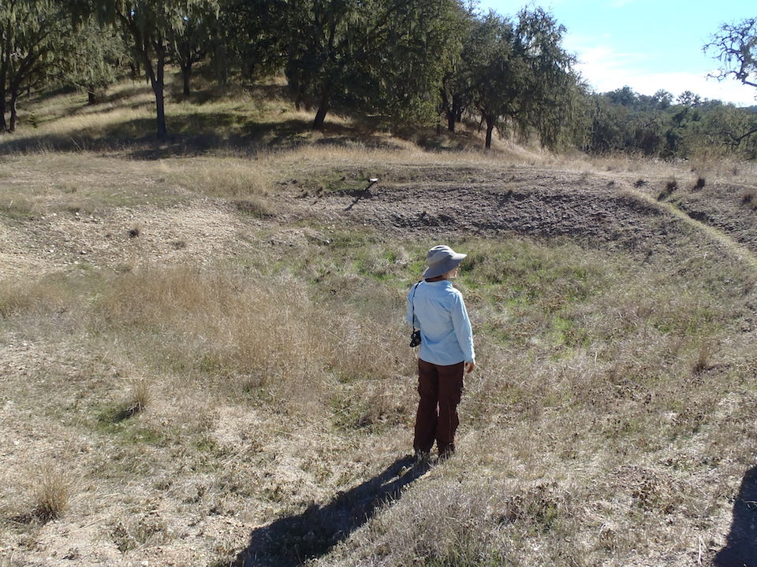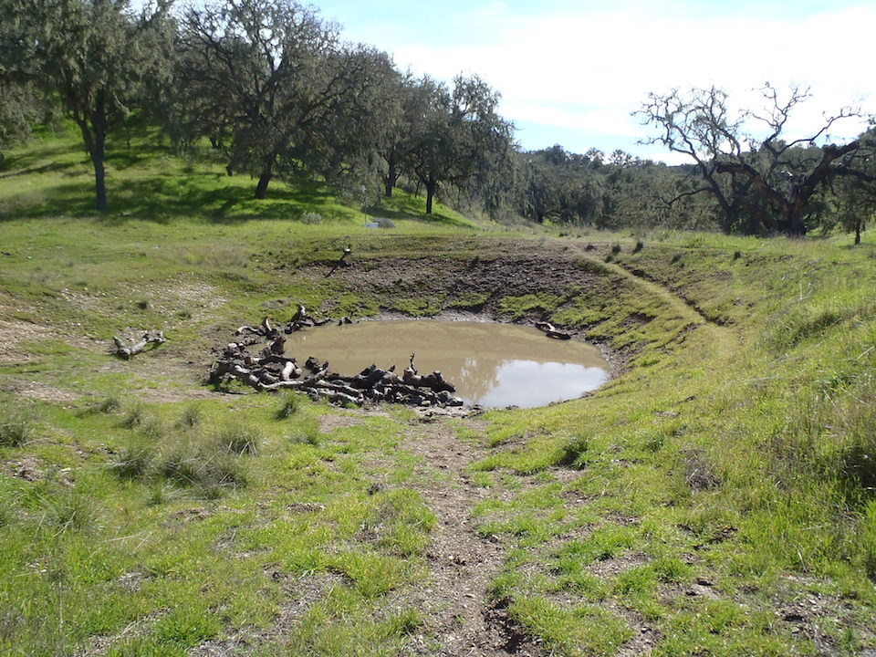

Left: Goldfinch Pond on November 15, 2016 before restoration.

Right: Goldfinch Pond on March 17, 2017 after restoration.

**Amphibian habitat suitability**

This pond was deepened by the Reserve in December 2016 so that it would be more likely to hold water for amphibian breeding during the 2017 rainy season. The images above show the pond before (left) and after (right) restoration and winter storms. This pond held water throughout the winter rainy season, although pond levels declined rapidly between January and February storms. The pond was approximately 10 meters x 10 meters with a maximum depth of 0.4 meter when we conducted the habitat assessment on February 18, 2017. Substrate consists of mud and grass, and some oak branches and logs provide substrate for egg mass attachment and amphibian cover. This pond provides excellent habitat for pond-breeding amphibians, especially Western spadefoot toads (*Spea hammondii*); however, we did not observe Western spadefoot toads during our survey. We observed adult male Pacific chorus frogs calling in the pond and Western toads soaking in the pond. On our final night of surveys on March 17, we observed thousands of tadpoles, too small to identify but presumably Pacific chorus frogs based on our previous observations of egg masses from that species and no previous observations of Western toad egg clutches.

**Total amphibian observations at Goldfinch Pond:**

|  |  |  |  |
| --- | --- | --- | --- |
| **Species** | **Egg masses** | **tadpoles** | **juv/adult** |
| Western toad | 0 | 0 | 3 (observed) |
| Pacific chorus frog | 60 | 2000 | 4 (heard); 6 (observed) |

**Non-native species:** None observed.

**Recommendations:**

This pond and the surrounding grassland habitat provide excellent habitat for Western spadefoot toads and California tiger salamanders; therefore, we recommend that appropriate upland and aquatic surveys be conducted specifically for these species as described above under recommendations for Cloud’s Rest Pond. We recommend continuing to monitor this site for these species and ensure that the pond remains free of non-native predator and competitor species such as fish, crayfish, non-native tiger salamanders (*Ambystoma mavortium*) and bullfrogs (*Rana catesbeiana*).

### Site 7 - Goldfinch Trough

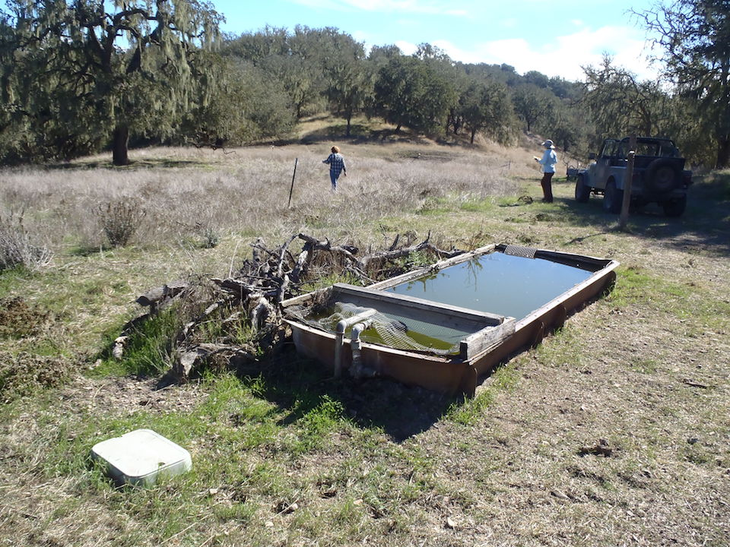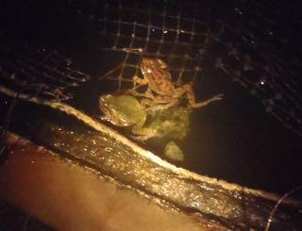

Left: Goldfinch Trough on November 15, 2016.

Right: Two Pacific chorus frogs in Goldfinch Trough on January 20, 2017.

**Amphibian habitat suitability:**

Goldfinch trough is a livestock watering tank, 3.2 meters by 1.1 meters, with a maximum depth of 0.5 meter. The substrate is metal trough matted with algae. It remains perennial as it is fed by a water pipe. We observed Pacific chorus frog breeding in this trough. On the third round of surveys, there were at least 1000 tadpoles in the trough, and over the course of the surveys, we observed numerous egg masses. One dead, gravid female Western toad was found in the trough on February 18; it appeared to have mold growing on it, as did the Pacific chorus frog eggs that were also in the trough. We were unable to determine the cause of death, and removed it from the trough to prevent its further fouling the water. There was a screen that would have allowed the toad to escape the trough had she wanted to, though we are not sure how long the water level had been that high since it had rained recently and we were unsure whether the water pump remains on during winter.

**Total amphibian observations at Goldfinch Trough:**

|  |  |  |  |
| --- | --- | --- | --- |
| **Species** | **Egg masses** | **tadpoles** | **juv/adult** |
| Western toad | 0 | 0 | 1 |
| Pacific chorus frog | 53 | 1050 | 3 (heard); 4 (observed) |

**Non-native species:** None observed.

**Recommendations:**

Goldfinch trough appears to be adequate habitat for successful Pacific chorus frog breeding. We recommend ensuring that there are adequate escape routes for amphibians, such as Western toads, in the trough at all water levels.

### Site 8 - Hidden Spring

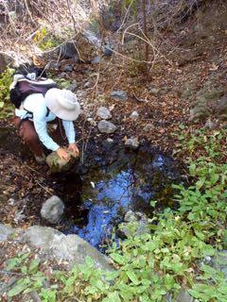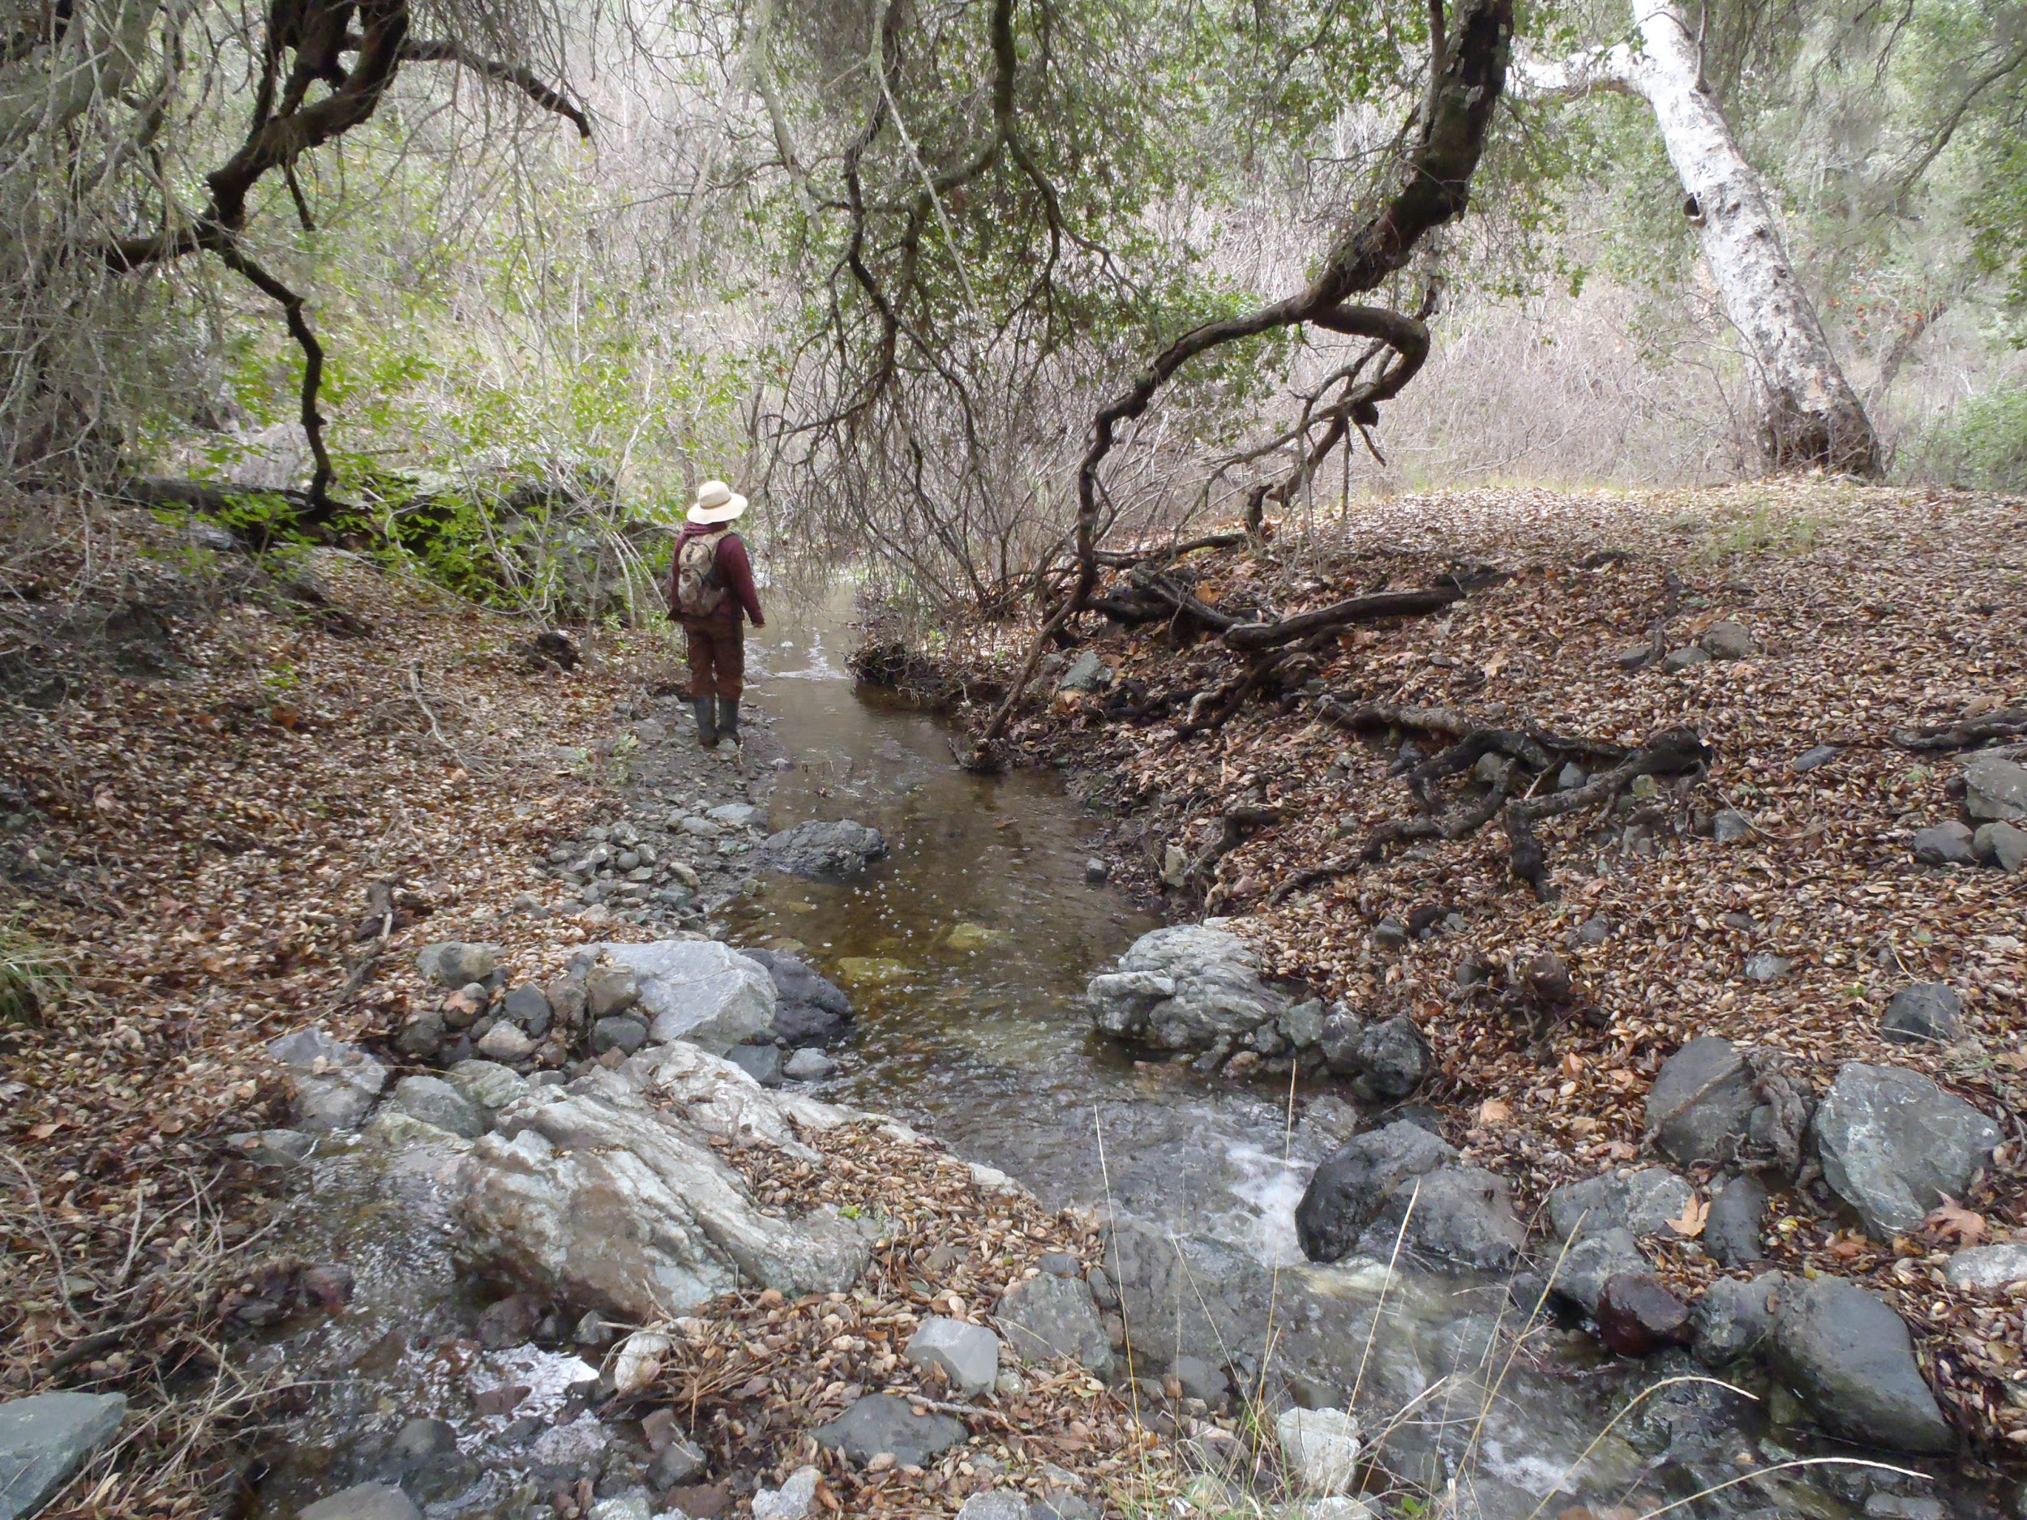

Left: One of the perennial pools in the dry creekbed on November 15, 2016.

Right: Figueroa Creek on January 21, 2017.

**Amphibian habitat suitability:**

This site includes upper portions of Figueroa Creek, which flows seasonally, and two perennial pools that are fed by a small spring. A terrace next to the creek has large oak trees. The pools are upstream of the oak terrace in a gulch with steep sides and dense vegetation. On the initial scouting visit on November 15, 2016, the creek was dry and only the two small pools held water. We conducted 3 day surveys and 3 night surveys at this site between January 21 and March 18, 2017. By the January visit, the creeks were flowing and the perennial pools were transformed into larger pools on the creek. The creek remained flowing through the last site visit on March 18. Despite appearing to be ideal habitat for amphibians including California red-legged frogs and California newts, no amphibians were observed. Fallen tree limbs, rocks, and leaf litter were also turned on the oak terrace to search for amphibians but none were found. Approximately 100 yards downstream, two Pacific chorus frogs were heard calling but that portion of the creek could not be accessed due to dense vegetation and poison oak.

**Total amphibian observations at Hidden Spring:**

|  |  |  |  |
| --- | --- | --- | --- |
| **Species** | **Egg masses** | **tadpoles** | **juv/adult** |
| Pacific chorus frog | 0 | 0 | 2 (heard) |

**Non-native species:** None observed.

**Recommendations:**

We recommend that this site continue to be monitored for the presence of amphibians as it appears to be ideal habitat. More amphibians may be observed later in the season when flow is lower.

### Site 9 - Ladder Trough

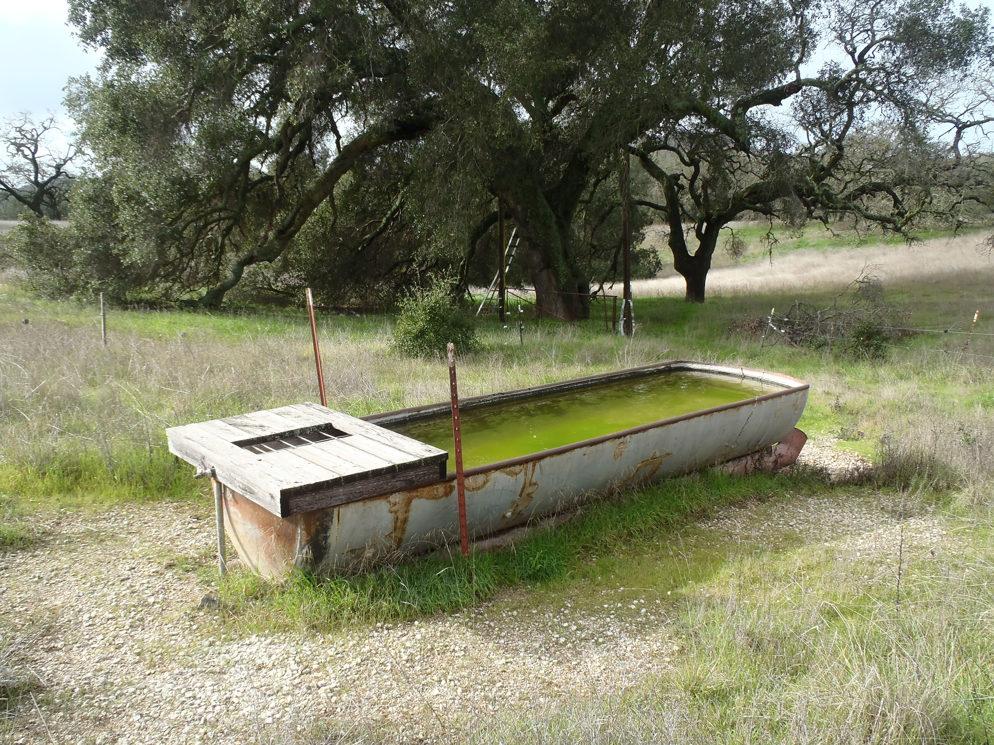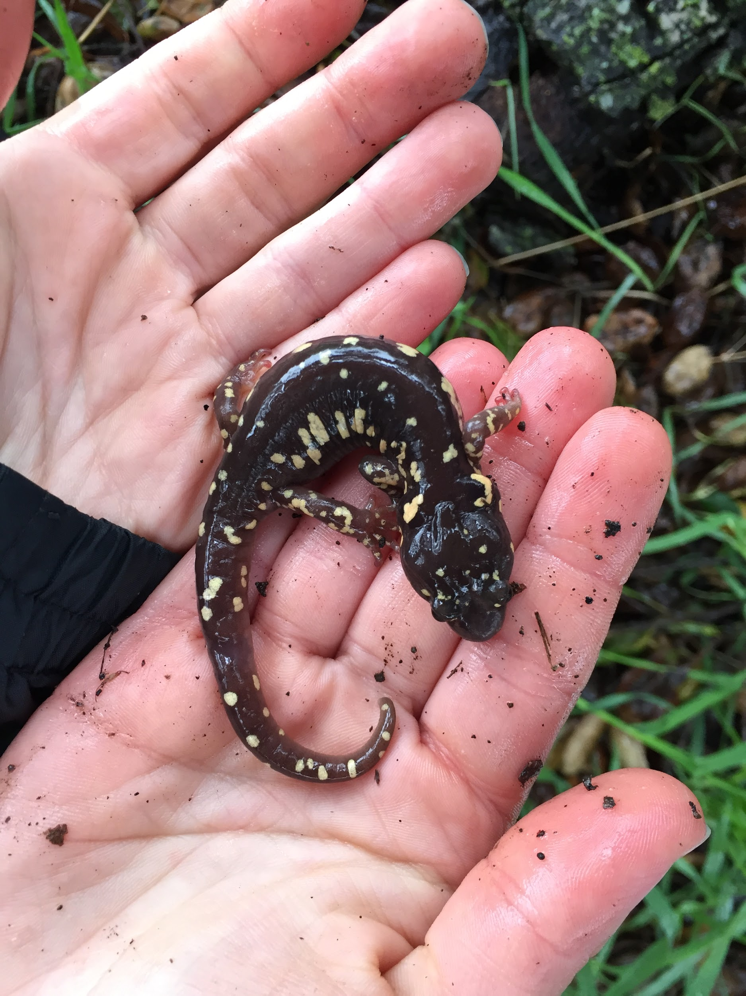

Left: The Ladder Trough on January 21, 2017.

Right: Arboreal salamander observed under a nearby oak on February 18, 2017.

**Amphibian habitat suitability:**

The Ladder trough is a long, metal livestock watering trough, approximately 4 meters long and 1 meter wide, with wooden planks at one end. During a survey conducted on February 18, 2017, the trough was approximately 1 meter deep. Water appears to be fed through a pipe so it could hold water year-round. The substrate consists mostly of algae. Dozens of notonectids were often observed in the trough. We conducted three day surveys and three night surveys at Ladder Trough between January 21, 2017 and March 18, 2017. On a rainy day survey on February 18, we overturned logs under the large nearby oak tree and observed one arboreal salamander (*Aneides lugubris*). We observed Pacific chorus frog egg masses, tadpoles, and adults in Ladder trough.

**Total amphibian observations at Ladder Trough:**

|  |  |  |  |
| --- | --- | --- | --- |
| **Species** | **Egg masses** | **tadpoles** | **juv/adult** |
| Pacific chorus frog | 10 | 3 | 5 (observed) |
| Arboreal salamander | 0 | 0 | 1 (observed) |

**Non-native species:**

None observed.

**Recommendations:**

Ladder trough appears to provide suitable breeding habitat for Pacific chorus frogs up to the tadpole stage. The wooden plank at one end of the ramp may provide suitable cover for metamorphosed individuals. We recommend continuing to supply water to the Ladder trough during the breeding season so that it can provide suitable breeding habitat for Pacific chorus frogs.

### Site 10 - Massey Spring

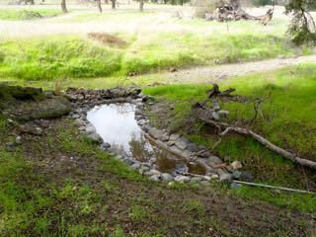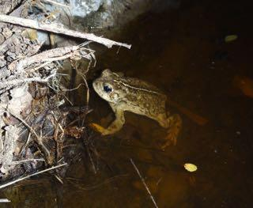

Left: Massey Spring on the February 21 survey.

Right: A female western toad found in the pool on March 18 night survey.

**Amphibian habitat suitability:**

This site is a concrete-lined perennial pool, approximately 1.2 meters by 4.3 meters with a maximum depth of 14 centimeters, fed with a pipe from a neighboring spring. The pool is on the terrace immediately next to upper Figueroa Creek in a grassy area under a large oak tree. We conducted 3 day surveys and 3 night surveys at this site between January 21 and March 18, 2017. The only amphibians observed at this site were two female western toads on the March 18 night survey. One was soaking in the pool while the second was in the creekbed immediately below the pool where there are logs and debris.

**Total amphibian observations at Massey Spring:**

|  |  |  |  |
| --- | --- | --- | --- |
| **Species** | **Egg masses** | **tadpoles** | **juv/adult** |
| Western toad | 0 | 0 | 2 |

**Non-native species:**

None observed.

**Recommendations:**

The spring pool should be checked periodically to ensure that it has water and to remove debris from the deeper portions where it accumulates. A branch could also be placed in the pool to provide western toads a structure to wrap their egg strands around, which might encourage breeding.

### Site 11 - Tipton House Pond

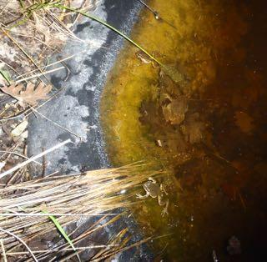

Pacific chorus frogs in the pond on the February 3, 2017 survey.

**Amphibian habitat suitability:**

The pond in front of Tipton House is artificial, with plastic substrate that has been placed in the ground. Its shape is irregular, and it measures approximately 2 meters by 1.5 meters at its widest points. It has a maximum depth of 22 centimeters. We conducted two day surveys and three night surveys at this site. We decided to include this site in our surveys after hearing a cacophony of Pacific chorus frogs calling at this site on February 3, 2017. On that evening, we observed 26 Pacific chorus frog adults, including 7 amplexing pairs. Two weeks later, we counted 26 Pacific chorus frog egg masses and a single adult male. On our final day survey, we observed more than 30 Pacific chorus frog egg masses, 30 tadpoles, and a single adult. This site appears to be excellent breeding habitat for Pacific chorus frogs.

**Total amphibian observations at Tipton House Pond:**

|  |  |  |  |
| --- | --- | --- | --- |
| **Species** | **Egg masses** | **tadpoles** | **juv/adult** |
| Pacific chorus frog | >50 | >30 | unk (heard); 28 (observed) |

**Non-native species:**

None observed, although a dead black rat was found in the pond on March 18, 2017. We removed it to avoid its fouling the pond water.

**Recommendations:**

We recommend keeping mosquitofish out of this pond, at least during the amphibian breeding season. This pond is small enough that it could be drained to remove the mosquitofish and refilled prior to the amphibian breeding season.

### Site 12 - Vernal Pools

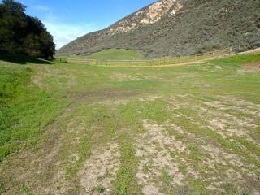

Vernal Pools site on the February 2, 2017 survey.

**Amphibian habitat suitability:**

The Vernal Pools site is in an open, grassy area on a neighboring property. We conducted 3 day surveys and 2 night surveys at this site between February 3 and March 17, 2017. One of the pools was just starting to fill on January 20, but on February 3 it had gone dry, with the mud at the bottom just beginning to crack. On February 18, it held water, measuring approximately 6 meters by 5.5 meters, with a maximum depth of 3.8 centimeters. On our March 17 survey, the pond had gone dry again, and appeared to have been recently graded. This grading could crush amphibians in underground burrows at the site. We observed no amphibians during our surveys at this site, but it did not hold water long enough to attract successful breeding.

**Non-native species:**

None observed.

**Recommendations:**

Since the grassland was graded this season, the pools may no longer have the ability to hold water long enough to support amphibian breeding. We recommend restoring the pools by recontouring and possibly relining them so that they can hold adequate water again.